LEARNING DEMOCRACY IN STUDY CIRCLES

www.sif.lv
www.eeagrants.lv
www.eeagrants.org

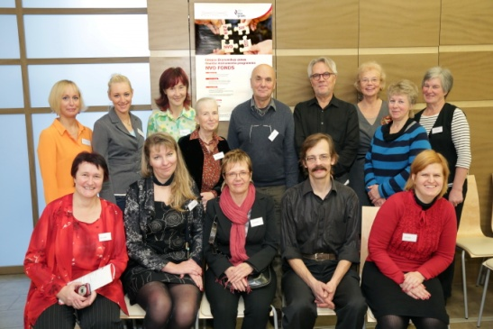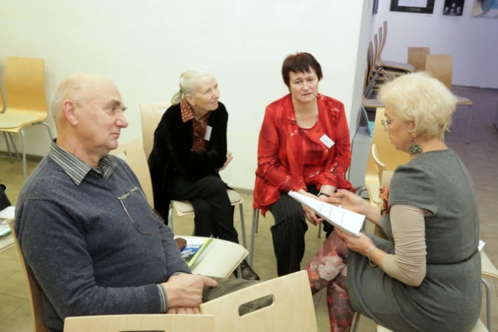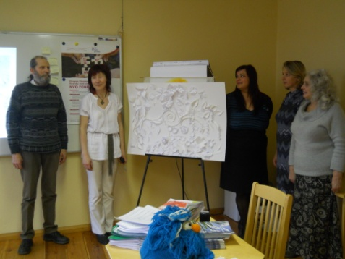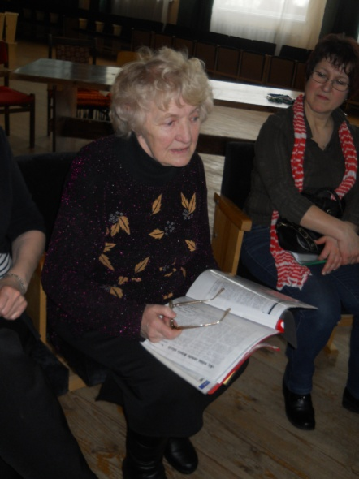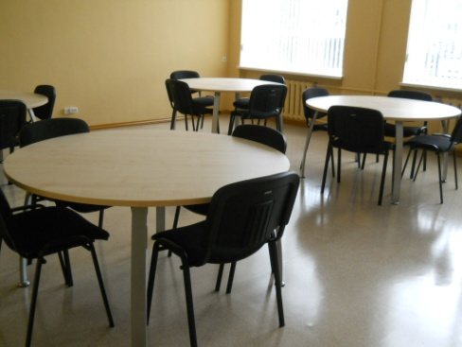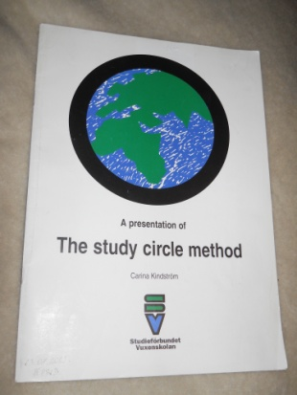

About the author
Education background from Norwegian universities in sociology, social science and adult education (master level), management skills from functions as director of publishing, adult education centers and NGOs. Teaching skills from adult education centers and adult education associations.
Organisational skills from positions as board members of the European Association for the Education of Adult and the International Council for Adult Education.
Sturla Bjerkaker also has been Director/Principal at the Nordic Folk Academy which organized seminars for participants from Baltic 1990 to 2005. In 1990 – 1995 he was among those who started "Nordic Baltic Summer Academy".
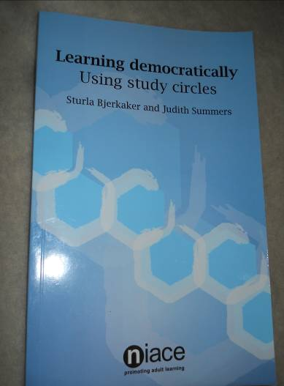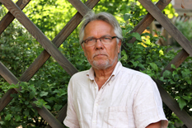
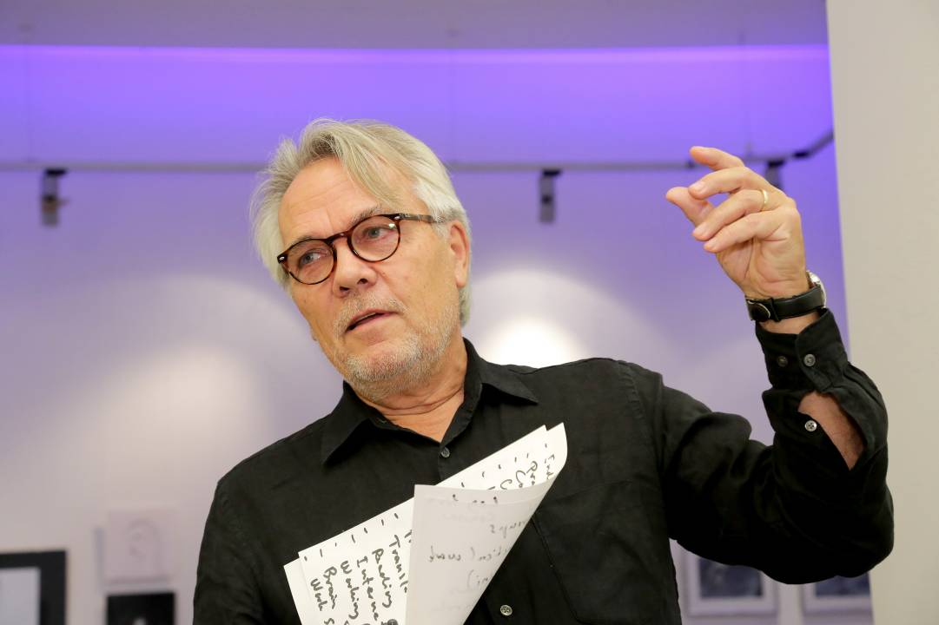
Material is combined with illustrative material from project „Democratic Study circles”
Photos: Jānis Brencis, Rita Liepiņa, Ginta Kristjansone, Laura Liepiņa

Adult learning benefits societies

"You can´t learn if you are afraid; you can´t learn if you are deprived; you can´t learn if you are hungry", concluded Sturla Bjerkaker, treasurer of International Council of Adult Education (ICAE) at the workshop Lifelong Learning in Development Cooperation - An Unfinished Agenda, organized by EAEA and DVV International at the European Development Days (EDD) on the 26 of November 2013.
Uwe Gartenschlaeger, Vice-President of EAEA, and Deputy Director of DVV International said the shift in focus from the Millennium Development Goal of universal primary education for all to a cradle-to-grave education cycle had given adult educators an opportunity to shape the future.
With those remarks, delegates entered into a debate on development strategies and identifying synergies needed for tackling the global challenges facing education and development.

Community involvement crucial
The primary concern that emerged was that lifelong learning in the post-2015 development agenda will need to put the learner´s wishes and needs at the heart of the process. Engaging learners´ voices is vital to ensuring sustained participation and involvement.
"Community involvement is needed for learning. If you are surrounded by a safe culture and a safe community which supports you, you will not be afraid of taking the opportunity of education as an adult", said Sturla Bjerkaker.

Adult education - a good tool for development
Gina Ebner, Secretary General of EAEA, reminded that European lifelong learning policies provide a foundation for development around the world and must be tailored to the needs of individual countries.
In discussing the key lessons of the European lifelong learning process for development cooperation, delegates concluded that raising levels of investment is crucial to ensure the sustainability of projects, so that people continue to learn throughout adulthood.
"We need to look at what makes adult education a good tool for the transformation of society in a positive dimension", said Balázs Németh.

An unfinished agenda
Lifelong learning is a key for achieving social change and reducing poverty levels around the world. It has the capacity to positively affect many dimensions of poverty, peace and reconciliation, as well as conflict prevention.
Adult education creates change through enhancing employment prospects, improving health levels and financial literacy, as well as giving people better chances of acquiring the tools needed to run their own lives. However, these benefits are often not understood outside the educational discourse and there is a lack of recognition of the education sector when looking at development goals, in particular non-formal adult education.
Policymakers and even civil society organisations often do not include education interests in their work. As a result, the respective UN Millennium Development Goals and ‘Education For All’ targets for 2015 will mostly be missed, especially the goals of the latter that explicitly affect adult learners.
The session aims to share experiences, brainstorm and work towards a formulation of a lifelong learning goal for the Sustainable Development Goals, the implementation of the European Lifelong Learning agenda in the European Union´s Development Cooperation and the possibility of Using Europe´s adult education network for Development cooperation.

Synopsis
Lifelong learning in the post-2015 development agenda will need to put the learner’s wishes at the heart of the process if it is to be an engine of growth, said delegates.
Introducing the brainstorming session, Uwe Gartenschlaeger, Vice-President of the European Association for the Education of Adults, said the shift in focus from the Millennium Development Goal of universal primary education for all to a cradle-to-grave education cycle had given adult educators an opportunity to shape the future.
With those remarks as a foundation, delegates enter into a debate on development strategies and identify synergies needed to for tackling the global challenges acting as a barrier to change in order to design education for the world they want.
The primary concern that emerged from all four brainstorming collectives was that while teachers are at the centre of quality education, the position of the learners themselves needs to be paramount in strategy development and service provision.
A clear message from delegates was that engaging learners’ voices is vital to ensuring sustained participation and involvement. Examples of putting learners first included:
- Training female teachers to work in regions where there are cultural barriers to women being taught by a man, particularly given that of the one billion adults still unable to read and write, two-thirds are women;
- Recognising the need for educators to understand the social context in which education takes place and opportunities for issues such as reconciliation;
- Working in partnership with the private sector to encourage businesses to allow employees to access formal and non-formal education;
- Creating a safe culture for learning through community involvement in designing education provision.
‘Community involvement is needed for learning. If you are surrounded by a safe culture and a safe community which supports you, you will not be afraid of taking the opportunity of education as an adult,’ said Sturla Bjerkaker, Treasurer at the International Council of Adult Education.
In discussing the key lessons of the European lifelong learning process for development cooperation, delegates concluded that raising levels of investment is crucial to ensure the sustainability of projects, so that people continue to learn throughout adulthood.
‘We need to look at what makes adult education a good tool for the transformation of society in a positive dimension,’ said Balázs Németh, Associate Professor of Lifelong Learning at the University of Pécs, Hungary.

Searching for the truth

- It has been three years since Norway adopted a new Adult Education Act, stating ambitious goals for the operations of adult learning associations*. But no-one can tell the effects. To avoid fumbling in the dark, the Government recently initiated research – to find "the truth" about Adult Education in Norway and create a foundation for future policies.
- A 20-year wait

- The Norwegian Government has now initiated two research projects. The biggest one is a 3 million Euro project on Adult Education in general – taking place within a five-year period. The other one is a 125,000 Euro project focussing solely on the adult learning associations – being carried out in 2013. It has been 20 years since we had any significant research on adult learning associations, so this is about time, says Secretary General in the Norwegian Association for Adult Education, Sturla Bjerkaker.
- Not much known

- Bjerkaker's statement about the lack of research is supported by the research institution in charge of the project, Oxford Research. In their information letter about the project, they state: "There is little research-based evidence on how adult learning associations' training is a supplement to the training of formal adult learning providers. The effects of non-formal education on the individual and the society are not well documented." Finally, Oxford Research state: "We don't know much about the adult learning associations' status in society, or their role and responsibilities in relation to the member organisations. The research project is intended to encompass the activity that is eligible under the Adult Education Act, but also the activity of other kinds of adult education carried out by adult learning associations, and to see these types of activities in context."
- Sacrificed on behalf of employability
- "Of course we expect this research to document the excellence of adult learning associations," claims Sturla Bjerkaker, half-joking. He regrets that adult learning associations and non-formal adult learning are the neglected part of adult education in his country. "The broader perspective on learning as a tool for inclusion and participation is sacrificed," says Bjerkaker. "Now it's almost all about formal competencies and employability." He claims that this will be a disadvantage for our society in the long run. His hope is that the newly initiated research will better document the effects of non-formal education on individuals and the society.
- A piece of the pie
- The larger research project is a mission from the Research Council of Norway. The project is not yet underway, but a reference group has been assigned. Kjærsti Gangsø, who is managing director of one of the adult learning associations, is representing the adult learning associations in this reference group. She is determined to get a significant part of the project to focus on the non-formal sector.
- "Organisations within the voluntary sector in Norway make a large contribution to Norwegian economy and civil society, and I'm certain that non-formal learning is required to maintain and develop these organisations," Gangsø states.
- 1) Does a local voluntary organisation with a high amount of non-formal learning survive longer or better than organisations with or without a lower amount of learning? And will organisations with a higher learning activity become more robust? And do they increase the recruitment of participants and generate more voluntary activity?
2) Do training and non-formal learning in the voluntary sector provide any benefits beyond providing knowledge on the subject held in the course?
3) What motivates people to participate in systematic training in voluntary organisations? Does this kind of learning have the same source of motivation as learning in the workplace, or are there other factors?

About VOFO

- Voksenopplæringsforbundet (VOFO), in English - Norwegian Association for Adult Learning (NAAL)
- Website:
- www.vofo.no
- The NAAL is the national NGO umbrella for adult learning in Norway. The members are 19 governmentally approved adult learning associations with a member network of 438 nationwide adult learning NGOs. NAAL has a central administration in Oslo, and has autonomous regional offices covering all 19 counties of Norway. Members' activities in 2009: approximately 35 900 courses with 470 000 participants.

- The purpose of NAAL is to:
- Advocate the common interests of the associations and their participants towards the Government, the Parliament and the Ministry of Education, promote non-formal adult learning in the society in general, counsel members and other third parties concerning laws and regulations, advice within the field of Adult learning theory and practice, project coordination, advocacy and lobbying.
- The members of NAAL represent a multitude of interests and ideologies. The largest associations offer a broad range of learning opportunities on several levels, with or without formal exams and parallel programs in the official school system. Other associations emphasize more voluntary adult learning activities, organizational training of members, learning for the development of the local community and sustainable development. Others emphasize political training, culture and creative, esthetically and practical topics. In 2012 our members activities totaled 40 000 courses with 500 000 participants. The common lowest denominator of the adult learning organized by the NGOs is a profile of equality and equal opportunities, a humanistic adult learning theory and practice, a belief in every person's development potential. NAAL regularly signs up to international projects as a project partner. They strive to put together project teams that fully meet the requirements of the project initiator. NAAL has a policy to sign up as the main project partner and then internally subcontract to our members. This way NAAL keeps the transparency and openness that is needed in democratic structure.

Government support to NAAL
As a result of the Norwegian Adult Education Act of 1976, the adult learning organised by the member associations of NAAL receive, through a legal system of criterias, grants from the Government, most of the counties and many municipalities. The Governmental grants for 2012 was 189 054 000 NOK.
In 2009 a new Adult Education Act was created, and it was active from 01.01.2010. The new Act is expected to change the criteria for grants slightly, but is not expected to change the level of grants particularly.

Five Top Tips for Adults Returning to Education

1. Develop a Network
Returning to education after a long period can seem very daunting. Developing a network of friends and acquaintances can greatly enhance your experience. Adult learners often fit their classes and study time around family and other commitments and may not spend a great deal of time at their place of learning. Some people will be studying part time and may spend even less time there. Developing a group of friends who you can discuss course work and assignments with and borrow or swap notes with if you miss a class is very important. Classmates can also offer a great source of support when you are feeling overwhelmed and need a bit of extra help or reassurance. Make a positive effort to meet new people at the start of your course, even if it's grabbing a cup of coffee at a break. Remember that everyone is in the same boat as you.

2. Get Involved
The first few weeks of your course are the best time to meet other people. Attend classes and lectures and ask questions if you are unsure, the chances are 90% of the class are thinking the same thing but are too shy or nervous to ask for fear of looking stupid. Get to know your lecturers or tutors and remember they are there to help you. Get to know your surroundings whether it's the library, the coffee shop or the Students Services. The more time you spend there the more you will start to feel comfortable and begin to enjoy the experience.

3. Plan Your Time
Time Management is crucial for everyone when returning to education, particularly for adult learners who are often juggling education with family and other commitments. A timetable can be useful to help you keep track of your time. Make a list of all your commitments and classes and then fit in study time around this. Learn to prioritise and except that you can't do everything, but you can always do something. Start projects and assignments early, it will save you a lot of stress and headaches and will avoid any panic the night before it's due.

Five Top Tips for Adults Returning to Education

4. Use Technology
Returning to education can bring many challenges and using computers and the internet can be one of them. Use this as an opportunity to upgrade your computer skills. Computer technology is often used extensively through colleges and universities for learning and can be a great tool for accessing resources and completing course work. Some courses may also have online groups where you can discuss topics and assignments. Ask what computer supports and access is available to you at your place of learning.

5. Know where to get help
A lot of adult learners will face challenges at some stage of their learning. Without adequate support problems can feel much bigger than they actually are. You do not have to handle them on your own. Remember there are lots of people who can help and support you but it's up to you to ask for assistance. Many colleges and universities have an Access Officer or a Mature Student Officer and they will be able to give you advice. Check out what supports are available to you and do not hesitate in asking for help.

There is no alternative to democracy

I recently had a very interesting conversation with friends on our all-time favourite topic: democracy.
In light of the recent disturbing events in Egypt, pro-authoritarian regime sentiment resurfaced stronger than ever: democracy should be delayed to leave the path for economic growth as it happened in China, Singapore or even Rwanda— readiness is not a prerequisite to human rights. I have no doubt democracy will soon flourish in the Middle East and North African region. Call me an idealist; but I will not change my mind. We can debate how much time it will require, the path it will take, or on the actors it will necessitate. But that’s not what I want to discuss here.
I am someone who believes democracy is not only a means but an end in itself. Last year, I spent a year in Kenya, visiting disconnected areas but still feeling a genuine search for political participation among the population. My experience reinforced my belief that there is no alternative to democracy.
Democracy has its own challenges. The list is long but corruption and tribalism might probably be the nastiest ones affecting developing countries. In sub-Saharan Africa, you often notice that democracy and elections are the two sides of a corrupt government coin. Examples are numerous and detractors of democracy rush to argue against democracy. Does it mean we should give up on the idea of democracy? Never.
Anything different from democracy runs contrary to our values, to our interests, and to the intrinsic wishes of the people on the ground. So what is wrong with the people that we choose? Why is democracy so difficult to implement? The problem is not the people that you chose. The problem is that you chose them. I have not met, in Kenya or elsewhere, even in the most isolated communities, anybody who does not want a say in who governs them. I have never met a farmer who does not want to vote.
So we must concede that despite the hesitant statistics, despite the fact democracy is often referred as the ‘’worst form of government’’ quoting Churchill, democracy is something we should fight for. In order to do so we need to get away from insane, instrumental arguments. We need to distance ourselves from saying democracy is important because of the other things it generates. We need to get away from thinking, in the same scheme, that human rights matter because of the other things they bring, or indeed that women’s rights matter for the other things they bring. Those arguments are very dangerous, and we should erase them from our equation.

There is no alternative to democracy

Let’s argue, for example, that torture is wrong because we do not obtain good information in the process or that women’s rights are critical because they stimulate economic growth by doubling the size of the work force. What is wrong in this conclusion? It is wrong because any authoritarian government will turn and say; ‘Actually, we do have a lot of success extracting good information with our torture at the moment’ or ‘Our economic growth is considerable, thank you very much, way better than yours, so maybe we do not need to implement a programme on women’s rights.’
Democracy is not an instrument. Democracy is not crucial because of the things that it brings. The essence of democracy is not that it delivers legitimate, effective, prosperous rule of law. It is not that it guarantees internal or international peace. The point about democracy is intrinsic. Democracy matters because it reflects an idea of equality and an idea of liberty. It reflects an idea of dignity—the dignity of the individual—the idea that each individual should have an equal vote, an equal say in the formation of their government.
But if we really want to make democracy vigorous, we need to get involved in a new project of the citizens and the politicians. Democracy is not simply a question of elections. It is a state of mind. It is a movement, and the most important part of this movement is honesty.
For any of these elements to work, the weight should be equally distributed between the politicians and the citizens. For politicians to be honest, the public and the media need to allow these politicians to be honest. If local democracy is to flourish, it is about the active and informed engagement of every citizen.

What is a Facilitator?

“A leader of processes, provider of tools and techniques that can get the work accomplished quickly
and effectively in a group environment. A facilitator assists participants to bring out the full potential
of every individual and the entire group.”
(Definition of a facilitator developed by participants from TC Facilitators).

A facilitator is an individual who’s job is to help to manage a process of information exchange. While
an expert’s role is to offer advice, particularly about the content of a discussion, the facilitator’s role
is to help with HOW the discussion is proceeding. In short, the facilitator’s responsibility is to
address the journey, rather than the destination.
(definition from the ‘business world’, taken from an online source)

A FACILITATOR IS…

A consultant who designs work sessions with a specific focus or intent.
An advisor bringing out the full potential of working groups.
A provider of processes, tools and techniques that can get work accomplished quickly and
effectively in a group environment.
A person who keeps a group meeting on track.
Someone who helps to resolve conflict.
Someone who draws out participation from everyone, to ensure the full potential of the group is
attained.
Someone who organizes the work of a group.
Someone who makes sure that the goals are met.
Someone who provides structure to the work of a group.
Someone who protects the work of a group from the overhead of a group.
Someone who is empathetic.
Someone who organizes space and time.

What a Facilitator isn't…

Changing the wording of a participant.
Refusing to record an idea (looks tired, gets distracted, too many ideas coming at once).
Getting involved in the content of the group work.
Fixing the group (even in the most loving way!)
Fixing the problem for the group.
Attaching to outcomes.
Judging comments of the group, liking some ideas better than others.
Flip flopping the agenda and work processes.
Manipulating people and behaviors through their own feedback.
Monopolizing conversation.
Taking sides on issues or people.
Being closed to group suggestions on the process
Trying to have all the answers.

WIKIPEDIA ABOUT STUDY CIRCLES

What is a study circle?
A study circle is a small group of people who meet multiple times to discuss an issue. Study circles may be formed to discuss anything from politics to religion to hobbies. They are differentiated from clubs by their focus on exploring an issue or topic rather than on activities or socializing. When they emerged in the early twentieth century they were based on a democratic approach to self-education and were often linked to social movements concerned with temperance or working class emancipation.
Study circle basics
Study circles are typically created by persons who discover a common interest; other study circles may be created to analyze and find solutions to social, political, or community problems.
Often there is no teacher, but one member usually acts as facilitator to keep discussion flowing and on track, and ensure that everyone has an opportunity to become as involved as he desires to be. Reading material and audio/visual aids are often used to stimulate dialogue.
Study circles may be introductory level, advanced level, or any level in between. Study circles may be sponsored or assisted by government or community officials and have specific outcome goals such as generating ideas or suggesting courses of action; or they may be entirely independent and self-sufficient, existing simply for the pleasure of increasing the knowledge of their members.
There is no one right way to do a study circle. The method is simple and suitable whether the discussion is for deeper understanding, for weighing options and making choices, for making recommendations that lead to action, or for academic study.
Study circles allow complex topics to be broken down into manageable parts. Single session programs can result in meaningful and productive dialogue, but study circles usually involve multiple sessions in order to fully investigate the question at hand. However, a study by Staffan Larson in 2001 concluded that while study circles foster participation they are only partly successful as civic change vehicles since their power to influence social action is weak.

History and evolution
The concept and practice of the study circle appeared in the late nineteenth century. Narodnaya Volya, a Russian populist organisation, made extensive use of them in the 1870s. The concept was taken up by the Georgian Social Democrat group Mesame Dasi in the 1890s. A youthful Joseph Stalin was involved in leading some of these.
The concept later developed in early 20th century Sweden as a part of the activities in popular movements, such as the temperance and the workers' movements.Oscar Olsson was a prominent proponent of them. Since these movements' participants were working class or small farmers the study circles were important in relation to these classes' growing political power in the early 20th century. The issues that were studied were already from the early period broad - it could be as well political and social issues as literature or even school topics. The population as a whole were generally literate as early as the 17th century, and therefore literacy training was not an important concern as a topic for study circles. Other nonformal educations as folk high schools and popular lectures were already present, when study circles were developed and there were various kinds of connections between these different forms of studies open for adults with only compulsory shooling as formal education. Study circles arose with ambitions to create an educated citizenry.
In Sweden today study circles are a mass phenomenon and have broad national support. Around 300,000 study circles have been reported each year since the 1970s.^{[8]} National educational associations receive annual subsidies from the national government and work with folk high schools (folkhögskolor), university short courses, correspondence study and distance learning, allowing citizens to understand and participate more fully in their communities and nation. The Swedish study circle model was successfully transplanted into American culture, most notably in the National Issues Forums (sponsored by the Domestic Policy Association in Dayton, Ohio) and the Bricklayers and Allied Craftsmen's Study Circle Program which began in 1986.

History and evolution

Today, with the growth of the internet, virtual study circles are possible, but the original model of face-to-face communication and real-world, rather than virtual, interaction retains its wide appeal.
Study circles are also being employed as a change process and development activity within corporations. Some of the same ideas and concepts of community study circles can be applied to internal issues such as diversity, race relations and community-focused giving.
Study Circles have been used extensively in Australia for some years to engage citizens in issues as diverse as Reconciliation between Indigenous and Non- Indigenous Australians, and tackling environmental disasters like Blue-Green Algae in the nations river systems. Adult Learning Australia has championed the use of study circles for many years. More recently the Australian Study Circles Network has developed as a central resource for study circle practitioners in Australia.

In brief:
STUDY CIRCLE method description
In the Study Circle learners share their knowledge (which can also be implemented through researches at home) and competences through discussion and activities chosen and done together. It’s a sort of peer learning during which each participant can learn from what the others have to say (sharing knowledge) and experience and improve other main key competences, such as problem solving, communication, listening, initiative, in addition to learning to learn. The trainer acts as facilitator contributing to focus on the main issue and encouraging the development and the correct use of the key competences.
Aims and expected results
The Study Circle: gives to everybody the possibilities to participate on an equal base to a training experience, during which the trainees are able to express and experience themselves as problem-solvers, in order to promote the auto-training through sharing experiences, knowledge and competences. Lets participants to express opinions on a local problem, to socialize with other people and share results.
Competences addressed
• Social-emotional skills;
• Communication/listening skills;
• Initiative;
• Learning to learn competence;
• Problem Solving.
Time for method implementation
The balance between the groups stages depend on the size of group and on the topics or tasks but might typically involve:
• 5 minutes: working individually
• 10 minutes: sharing and discussing in pairs
• 20 minutes: comparing and debating in fours or more
• 15 minutes: pooling and gaining an overview in a plenary.
Step by step implementation
The trainer can decide to use the Study Circle interchanging it with frontal lessons or other methods.
1. First step
is to have the proper classroom context: learners and trainer should be positioned in circle, everybody has the same “position” (a person with a doctorate has no more status than a person with a high school diploma. Value is placed not on having mastered someone else’s ideas, but on generating and communicating ideas of one’s own) and the atmosphere should be relaxing and familiar.
2. Second step
is to assign a task to the learners (for example if the training subject is art, the task could be “knowledge/information on Michelangelo”): the trainer will invite learners to share their present knowledge about that topic and then to decide how to get more info. The trainer will act as facilitator during this decision making phase.
3. Third step
is to put together info in order to build the common and shared knowledge on the topic. Only at this point the trainer, if expert of the subject, can add info and knowledge.
4. Fourth step
for the trainer is to evaluate the learning achievement (through test or other means).
5. Final step
for the trainer is to underline the competences that each learner displayed, promoting the reflection on the acquisition of new knowledge and of life skills used (including learning to learn).
Materials needed to perform the method
Considering that the methodology is based on the open discussion among the students, it doesn’t require particular material, apart from a nice learning setting. PCs for desk research may be suggested.
AIMS, OBJECTIVES, OUTCOMES -
STUDY CIRCLE METHOD

Aims and objectives
The Study Circle gives to everybody the possibility to participate on an equal base to a training experience, during which the trainees are able to express and experience themselves as problem-solvers, in order to promote the auto-training through sharing experiences, knowledge and competences generally people decide to participate to a Study Circle willing to express opinions on a local problem, to socialize with other people and share results based on the problem-solving and problem-setting methodologies, the Study Circle promotes the acquisition of knowledge as well as key competences such as communication, initiative, problem solving, and social abilities .
The Study Circle aims to answer to a need of training coming from the bottom, i.e. expressed by citizens (bottom-up demand), on many fields and matters, giving training opportunities as well as possibilities of social inclusion and integration at any age. It helps forming groups interested in improving their knowledge and competences and in finding solution to problems of the local community, compensating what the formal education system is not able to offer it can be considered as a way of “learning near home”.
Outcomes
Participation to the problem solving that the community is interested in: enhanced amelioration of conditions of life, increasing of relationships and social skills, communication competences, development of meta-cognitive skills, learning how to use learning time, finding materials and tools, to overcome and use bonds, etc.

WHY SHOULD YOU ORGANIZE STUDY CIRCLES?

Organizing a study circle -- or a community-wide program of study circles -- is a lot of work, but it's worth it for a number of reasons.
People find study circles valuable because:
- The discussions begin with people talking about their own experiences. Study circles don't deal with problems in the abstract - they deal with real problems that real people experience every day.
- The small groups help people of different backgrounds talk about difficult issues in a safe, respectful way. Large groups can be intimidating; but many people who are uncomfortable in a large group will open up more easily to a smaller one.
- People know that they are part of a larger effort, and they feel good about that.
- The study circle program as a whole empowers community residents. It helps people solve problems and take action in their own neighborhoods and communities.
Once study circle programs get started, they usually grow larger and stronger -- people come to enjoy working together on a common goal. Study circle participants often talk about how quickly the time passed, since the discussion was focused, honest, and productive. They also talk about how much fun they had getting to know one another.
So as you can see, there are plenty of good reasons to organize a study circle in your neighborhood. Are you ready to try? Let's go!

HOW DO YOU ORGANIZE A COMMUNITY-WIDE STUDY CIRCLES PROGRAM?

Example: Crime Wave in Milltown
Milltown, a historic neighborhood in a large Midwestern city, has always been a nice place to live, with a good mix of old and young, students and professionals, and single people and established families. In recent years, Milltown has also been home to an increasingly large Hispanic population. The various groups, while aware of one another, don't interact much, and lately there has been some tension between the Hispanic newcomers and longtime "Milltowners."
As if that weren't problem enough, Milltown has, in recent months, experienced a crime wave. For the most part, the crimes have been relatively minor -- a little graffiti here, a window broken there, someone's mailbox knocked over somewhere else. But things seem to be escalating; several car break-ins have been reported, and one man's townhouse was burglarized.
The residents of Milltown are understandably concerned about the problems facing their community. How can they bring the community together to stop the crime and make all the residents feel safe?

Before you get started, there are several things you'll want to consider.
- First, share the burden: solicit volunteers in the neighborhood that will help you organize the program. This will not only help you, but it will also give the participants a greater feeling of "ownership" over the process.
- Second, make it clear that all different backgrounds will be respected in the study circles. Otherwise, you'll foster the perception that only certain people's opinions or experiences matter -- definitely not the message you want to be sending!
- Third, make sure that people understand that this project will help people solve problems in the neighborhood, not just talk about them!
With these things in mind, you're ready to get started!

Get started!

Put together a core team of stalwart assistants.Talk to a few people you know well and have worked with before, and who would be excited about this project.
- Hold a pilot study circle. With your core team's help, think of ten or twelve people who might be interested in being pioneers! Give them a personal invitation to the pilot study circle and try out one or two sessions. At the end, ask them what they think of the process and how you can make it work in your neighborhood.
  - The pilot study circle can be held anywhere - a church basement, an empty classroom in the neighborhood school, the activity room in an apartment building, or even someone's home. Wherever you hold it, make sure it's accessible, easy to find, and comfortable. You may wish to provide refreshments to the participants, or see whether the participants would like to take turns bringing food and drink.
Make a list of groups and organizations in your neighborhood. To involve a large number of people, you need to tap into as many groups and organizations as you can. Make a list of all the schools, congregations, businesses, clubs, nonprofits, libraries, tenants' associations, scout troops, and other groups in the neighborhood. Also list key outsiders who work closely with the neighborhood, including police officers, public officials, and other government employees. Can you think of others?
Hold another pilot study circle with representatives from different organizations. Invite people from some of these organizations to another pilot circle. If you have more than twelve people, hold more than one circle. Try for a good mix of people in each.

Example: A Study Circle Is Born
Milltown, a historic neighborhood in a large Midwestern city, has always been a nice place to live, with a good mix of old and young, students and professionals, and single people and established families. In recent years, Milltown has also been home to an increasingly large Hispanic population. The various groups, while aware of one another, don't interact much, and lately there has been some tension between the Hispanic newcomers and longtime "Milltowners." As if that weren't problem enough, Milltown has, in recent months, experienced a crime wave.
Alma Huerta, a Milltown resident, decides to organize a community-wide study circle program in response to the stresses on her neighborhood. She asks her friend in the townhouse next door, Allison Browne, for help, and Allison is enthusiastic about the project. Together they recruit other participants for a pilot study circle: the minister at Allison's church, the real estate agent who sold Alma her townhouse, and the custodian at Alma's office building are all members. They meet in the Milltown Baptist Church's meeting room because the church is an easily-located landmark in Milltown, and also because Allison uses a wheelchair and the church is easily accessible to people with disabilities.
Alma begins the study circle by introducing herself and having all the participants introduce themselves. She says to the group, "We're all here tonight because we 're concerned about crime in Milltown. Tonight, we're going to talk about safety. Safety is a big concern, because when you don't feel safe, it's hard to work on any other priorities. So the goal of tonight's session is to help you talk about how to make our neighborhood a safer place to live and work."
During the first session, the group, co-led by Alma and Allison, discusses a number of questions, including:
- Do you feel safe in the neighborhood? Why or why not?
- What kinds of safety precautions do you usually take?
- What roles do the police play in making the neighborhood safer?
- What roles can you play in making the neighborhood safer?
The group has a lively discussion about safety in Milltown. At the end, the participants agree that study circles are a great idea, and they begin to plan for the future!

Form a study circle working group.
Ask all the people who've been involved so far to join a working group that will spearhead the initiative from this point forward. Make sure this group represents the different kinds of people who live in the neighborhood. Split the working group into groups of two and three to start the following tasks:
- Plan the kickoff. This is a large meeting that takes place just before the study circles begin to announce the project to the whole neighborhood. Invite one or two speakers who can describe the study circles and inspire people to take part. Provide refreshments, and leave some time for people to socialize and sign up.
- Recruit and train facilitators. If you can, find some people who are skilled at facilitating groups. Also, invite people who have the personality to be good facilitators--good listeners often make good facilitators. Give them information about study circle facilitation, and bring them together for a training. Make sure people understand the main rule: Facilitators are neutral, and must keep their opinions to themselves.
- Find sites and handle other details. Arrange for study circles to meet in schools, libraries, police substations, churches, firehouses, and businesses; in a pinch, use people's homes. If you can, provide child care, transportation, or other services that will help people take part. If possible, find volunteers to serve as recorders for the groups.
- Recruit people to join the study circles. Again, personal invitations work best. Get everyone on the working group to recruit people from their organization or circle of friends. Go door to door. Create flyers and signup sheets to pass out in the neighborhood. Get your information into local newsletters, church bulletins, and newspapers, and think of other ways to get the word out.
- Plan the action forum. This large meeting takes place at the end of a round of study circles. Beforehand, use the records from each group to identify the main areas of concern. At the forum, allow enough time for someone from each study circle to give a quick summary of its ideas (no more than five minutes each). Encourage people to sign up for action groups on the main areas of concern. Give the action groups some time to get acquainted and begin planning. Close the meeting with a speaker who will congratulate everyone on their efforts. Make sure there is food and time for socializing.
Example: A Successful Kickoff

Alma and Allison have held a second successful study circle, this one with different participants, and they have been delighted with the participants' enthusiasm. Everyone who has taken part feels that expanding the program would be good for Milltown, and a number of people pitch in to plan a kickoff meeting.
The Milltown Community Center donates the space for the meeting, and local restaurants and caterers, some of whose businesses have been affected by the recent crime wave, donate food. An electronics shop in the neighborhood even donates a 26-inch color television to be raffled off during the event.
The women then get the word out. They create colorful flyers (making prominent mention of that TV!), which they make available at grocery stores, in the library, on church bulletin boards, in schools, and in clinics. They make sure the information is clearly printed in both English and Spanish. They write a press release for the local newspaper, place a public service announcement on the local cable-access television station, and get blurbs about the kickoff placed in school and church newsletters.
While all this media work is important, most study circle participants are recruited through personal contact. Knowing this, Alma and Allison tell everyone they can about the group, and they ask those people to tell others. They talk to local clergy, police officers, agency directors, social workers, media personnel, school personnel, and anyone else they can think of.
When the big day arrives, some 750 Milltowners converge upon the Community Center, and enough residents sign up to make 10 good-sized study circles.

Keep the momentum going.
Talk to the action groups to see how they're doing. Try to get the local media to cover the action effort. Work with people who want to get a new round of study circles going.
- Now you're ready for the study circles to begin; keep in mind that as they go on, you'll need tosupport the study circles. How? Bring the facilitators together for a meeting so they can compare notes on how their groups are going. Start new study circles for people who are joining late. Collect the records from each circle to give you a sense of the discussions and to help you document the process.
- When the study circles end - usually after several months - it's time to hold the action forum. This is a chance to celebrate what your neighborhood has done, and to move from talk to action.

Example: Managing the Program
- Throughout the process, Alma and Allison continue to coordinate the overall study circle effort. In addition to each facilitating a study circle of her own, they meet regularly with the other facilitators to review records, keep track of common themes, and generally see how things are going.
- The other facilitators report that things are going well with their groups. The discussions, while passionate and sometimes heated, have led to new ideas, new understanding, and new hope. New connections are being forged, and new friendships are being made. Best of all, the participants feel empowered; they feel that they really are doing something to reduce crime in Milltown.

Pause and reflect
on what you've learned, and start planning the next round. Get the working group together and talk about how things went. Record (and celebrate!) Your achievements, and look for ways to make the program stronger. Give feedback and encouragement to volunteers. Use what you learned to plan for the future. Try to expand your working group. In this way, you can sustain and deepen your study circle program and continue to build a stronger neighborhood!
Example: A Fitting Conclusion
When the study circles end, it's time for another gathering at the community center -- this time an Action Forum in which the study circles' proposals for action can be discussed. The groups have come up with some good ideas to reduce crime in Milltown. In the course of the discussions, it emerged that a lot of the increase in crime could be attributed to several youth street gangs springing up in Milltown. So a lot of the ideas had to do with youth. For example:
- Working with the local police substation to set up an after-school youth basketball league for the teens of Milltown.
- Working with the Community Center to expand its menu of after-school activities for teens.
- Setting up a mentorship program with Milltown High School for at-risk youth.
- Holding an annual community-wide Cinco de Mayo block party to celebrate community diversity and draw the neighborhood closer together.
- Talking with gang members themselves to find out why they have gotten involved with gangs, what keeps them involved, what can be done to make them feel like more of a part of the community, and what can be done to discourage them from taking part in criminal activities.
Implementing these suggestions takes a lot of time and involvement on behalf of the Milltown residents, but their efforts pay off: A year after the study circles project began, crime in Milltown is down over 60 percent.

TIPS ON RECORDING AND FACILITATING A STUDY CIRCLE
The recorder and the facilitator are very important to each individual study circle. The facilitator keeps things moving and on track, and the recorder makes sure everyone's thoughts are written down. If you've taken on one of these key roles, here's a fuller description of what you'll need to do.

THE RECORDER'S ROLE
Each study circle needs a volunteer recorder to jot down some of the key ideas that come up. The recorder should not be the facilitator--both jobs are too important for anyone to have to pull double duty! The recorder's main job is to listen carefully and document what the group members talk about. Some people feel they can take good notes and still participate in the discussion. Others prefer to concentrate on listening. The facilitator's role

The facilitator has a key role in the study circle process. Here are some tips that will help you facilitate meetings effectively:
- Stay neutral. Use the power you have with the group wisely. Your role should never be to promote a particular point of view, but rather to further the discussion. By the end of the discussion, group members should not know your views on the issues being discussed.
- Be prepared. Think ahead of time how the discussion might go. This will allow you to give your full attention to the group.
- Let participants respond to one another. Encourage interaction among the group. If questions or comments are directed at you, try to deflect them to someone else. You should speak less than any person in the group.
- Don't let any one person dominate the discussion. If you allow people to interrupt or let one or two talkers take over, the more polite people will get angry and frustrated. At the first sign of trouble, refer to the ground rules the group has set.
- Draw out quiet participants. Don't put anyone on the spot, but watch for opportunities to bring quiet people into the discussion. Learn participants' names and use them.
- Keep the discussions on track. Since important issues are usually related to each other, it is easy for groups to move into other areas. Participants need the freedom to explore connections and ideas, but try to keep the discussion related to the session's topic.
- Allow for pauses and silences. People need time to think and reflect. Sometimes silence will help people build up the courage to make a valuable point. You may find it helpful to silently count to ten after asking a question.
- Don't worry about achieving consensus. Not everyone is going to agree on everything. There is no need for consensus--just try to help the group find some areas of agreement.
- When in doubt, ask the group. If you're having trouble enforcing the ground rules, or deciding which topic to spend time on, ask the group what they would like to do.

• Content Focus How does a Study Circle exemplify the core features of effective professional development
: This professional development activity is extremely focused. The target
audience is teachers of low-literacy adult ESL, and this study circle will specifically focus on
reading instruction for these learners.
• Active Learning: This professional development activity will involve a series of meetings for a small cohort of practitioners. Each meeting will involve discussion and sharing to identify innovative, evidence-based solutions to classroom concerns about learners and their
literacy development. Each meeting will be preceded and followed up by at-home reading and reflective classroom-based tasks that will generate richer and deeper discussions
during the study circle meeting.
• Coherence: This professional development activity is organized in a logical progression to
explore in depth several key issues in teaching this specific population of learners. Coherence is achieved by building on what teachers already know, exploring teacher beliefs on each topic and encouraging communication and openness to learning, and aligning improvements with state and program policies. The study circle will move in a circular fashion, first looking to relevant research on a specific topic, providing time and tasks to Study Circle Guide.
assure comprehension. Then, taking this new knowledge into account, study circle
participants examine connections from that research to their own classrooms and experience. Finally, specific tasks and subsequent reflection provide an opportunity to experiment with teaching techniques and approaches to literacy instruction that change and improve teachers’ practice and subsequently student learning.
• Duration: This professional development activity meets over a course of 6-8 weeks, roughly once every two weeks. The study circle meetings themselves will require 9 hours of contact time with activities, reflections and observations between meetings.
• Collective Participation: This professional development activity is a group endeavor,
bringing together practitioners from various sites and programs who share the common
experience of working with low-literate ESL learners. The participants’ various contexts
allow for unique sharing and networking during and beyond the study circle.

Diversity Study Circles
A study circle is a group of 8 – 12 people from different background and viewpoints, each having an equal voice, who meet several times to talk about an issue while understanding each others views. The idea is to share concerns and look for ways to make things better. A facilitator helps the group focus on different views and makes sure the discussion goes well.
The goals of these study circles
- To create a collaborative problem-solving environment
- To give voice and ownership in the diversity planning process
- To further the awareness and appreciation of diversity

Sample Circle topics
- Poverty and Socio-Economic Status: Is education our ticket out of poverty?
- Religious Diversity: Does religious freedom exist on our campus?
- Body Image: Am I what you see?
- The African-American Male: Why are black men disappearing from our campus?
- Race and Ethnicity: Racial profiling, cultural profiling, stereotyping… Let’s talk about it.
- Employment Status: Full-Time vs. Part-Time. Faculty, staff, and administration… Aren’t we all on the same team?
- Globalizing the Campus: Where are our jobs going? Are we prepared?
- Diverse Learning Styles: Why don’t they teach the way I learn?

Diversity issues in study circles
Cultural diversity and intergroup relations are at the heart of the most pressing community concerns. But as important as diversity issues are, community members may be reticent to talk about them. It's often only after a crisis that people realize "we have a problem here, and we should be working together on it." Even then, it's hard for people to know where and how to begin.
Your challenge as a study circle organizer will be to show people the way to begin. You will be working to welcome and include people from every part of the community. It will be important to show people that the study circles will be safe places where they can share their ideas, listen to others, and work together to make a difference on the issues that affect their lives.
There are a number of ways you can use this guide to build study circles. Think about what will work in your specific situation:
- what will bring out large numbers of community members?
- what will draw people from all parts of the community?
Central to all of the following strategies is a commitment to bring together a diversity of people for honest, respectful, democratic dialogue:
- Organize study circles on an issue of general concern to the community. Consider what will draw broad participation from all sectors and groups. Use all or parts of Toward A More Perfect Union and the materials in this AMPU Guide to address the diversity issues that underlie the specific issue your program will address.
Example: In Long Beach, CA, the Peace Among the People Initiative is bringing together people from Hispanic, Anglo, and Cambodian backgrounds for study circles on violence, which is of critical concern to all parts of the community. In these study circles (some of which are bilingual) many people will have their first opportunity to meet with fellow community members, discover common concerns, and begin to work together. Idea: In such a program, groups could use sessions 1 and 2 of this guide before addressing the specific issues of violence they are facing.

Diversity issues in study circles
- Organize study circles on race relations and racism. Often racial and ethnic tension is of paramount concern in the community, and so study circle organizers may want to begin with the more specific issue of race. In the process, other diversity issues frequently arise; some of Toward A More Perfect Union and materials from this Guide could be incorporated into those discussions. Or Toward A More Perfect Union in its entirety could be used at a second stage set of discussions to follow up the study circles on race.
- Organize study circles on the immigrant experience and what it means to be an American. Especially in communities where recent immigrants are settling, this may be a critical issue to a broad cross-section of people.
Example: In Somerville, MA, the Somerville Human Rights Commission and Tufts University sponsored a study circle program called Somerville Conversations on Ethnic Identity, and Immigrant Experience, and What it Means to Be an American. Supported by the National Endowment for the Humanities, other sponsors included the Somerville Haitian Coalition, Massachusetts Alliance of Portuguese Speakers, Centro Presente, the Disability Commission, and the Somerville Interfaith Group.
- Organize diverse study circles within particular sectors -- for example, within the faith community, or among schools. On a smaller scale than a study circle program that aims to include all parts of the community, these programs can consider the issues faced by particular institutions. After experiencing participatory discussion, some of the participants may become the leaders that carry the conversations to other sectors of the community.
Example: When congregations from different faith traditions and ethnic backgrounds pair with each other for dialogue, they have a chance to form new relationships, grapple with public issues, and build community. Participants have the opportunity to explore how their faith informs their perspectives. Idea: By using Toward A More Perfect Union in an Age of Diversity, people could explore religious diversity in the community.
Idea: Frequently, schools are racially and ethnically segregated. Even within "integrated" schools there is not a lot of interaction between groups. Either through school pairing or through study circles within a school, students could have the chance to explore their diversity and consider how to create a school community that works for everyone.

A study circle examines many perspectives.

The way in which study circle facilitators are trained and discussion materials are written gives everyone ‘a home in the conversation’ and helps the group deliberate on the various views and explore areas of common ground. A study circle progresses from a session on personal experience (‘how does the issue affect me?’) to sessions providing a broader perspective (‘what are others saying about the issue?’) to a session on action (‘what can we do about the issue here?’).
Study circles can take place within organisations, such as schools, unions, or government agencies. Yet, they have their greatest reach and impact when organisations across a community work together to create large-scale programs. These community-wide programs engage large numbers of citizens in a community - in some cases thousands -- in study circles on a public issue such as race relations, crime and violence, or an environmental education issue¹.

Objectives:
Study circles provide a venue for in-depth, regular, lengthy discussions that allow exchange of information on a particular topic or issue.

Outcomes:
Study circles develop better informed citizens who are then in a better position to manage their local natural resources, or to contribute to planning initiatives in relation to these resources.

Uses/strengths:
- Allows citizens to gain ownership of the issues, discover a connection between personal experiences and public policies, and gain a deeper understanding of their own and others’ perspectives and concerns.
- Since the dialogue does not promote one particular point of view or try to persuade people to take a specific action, potential coalition partners can usually find ways to work through ownership issues, mistrust, or genuine disagreement.
- Fosters new connections among community members that lead to new levels of community action.
- Can create new connections between citizens and government, both at an institutional level and at the level of parents and teachers, community members and social service providers, residents and police officers.

Four stages of group development and process
Groups, like individuals, go through stages in their development. B. W. Tuckman, a specialist in
group development, describes the process in the following way: forming, storming, norming, and
performing. Keep in mind that while study circles may develop in this way, it is not necessarily a linear
progression. Groups move back and forth among the various stages.
Forming is the initial period when group members are getting to know each other and figuring
out how the group will work. Members may be polite or cautious, and often look to the facilitator
for guidance.
Storming refers to the dynamic in a group when roles, status, and control are being explored.
Sometimes one-on-one alliances form, and conflict may emerge.
Norming means the stage when the group “settles,” and patterns of behavior and operation
become established. Trust and satisfaction are usually high.
Performing is the stage when the group is working well to meet its goals. Members have found a
level of comfort with each other. The group is making good progress, handles its conflicts
successfully, and appreciates its diverse members.

Good study circle facilitators

• are neutral; the facilitator’s opinions are not part of
the discussion.
• help the group set its ground rules, and keep to them.
• help group members grapple with the content by asking
probing questions.
• help group members identify areas of agreement and
disagreement.
• bring in points of view that haven’t been talked about.
• create opportunities for everyone to participate.
• focus and help to clarify the discussion.
• summarize key points in the discussion, or ask others
to do so.
And
• are self-aware; good facilitators know their own strengths,
weaknesses, “hooks,” biases, and values.
• are able to put the group first.
• have a passion for group process with its never-ending variety.
• appreciate all kinds of people.
• are committed to democratic principles.

How does a Study Circle exemplify the core features of effective professional development
• Content Focus: This professional development activity is extremely focused. The target
audience is teachers of low-literacy adult ESL, and this study circle will specifically focus on
reading instruction for these learners.
• Active Learning: This professional development activity will involve a series of meetings for a small cohort of practitioners. Each meeting will involve discussion and sharing to identify innovative, evidence-based solutions to classroom concerns about learners and their
literacy development. Each meeting will be preceded and followed up by at-home reading
and reflective classroom-based tasks that will generate richer and deeper discussions
during the study circle meeting.
• Coherence: This professional development activity is organized in a logical progression to
explore in depth several key issues in teaching this specific population of learners. Coherence is achieved by building on what teachers already know, exploring teacher beliefs on each topic and encouraging communication and openness to learning, and aligning
improvements with state and program policies. The study circle will move in a circular fashion, first looking to relevant research on a specific topic, providing time and tasks to Study Circle Guide.
assure comprehension. Then, taking this new knowledge into account, study circle
participants examine connections from that research to their own classrooms and experience. Finally, specific tasks and subsequent reflection provide an opportunity to experiment with teaching techniques and approaches to literacy instruction that change and improve teachers’ practice and subsequently student learning.
• Duration: This professional development activity meets over a course of 6-8 weeks, roughly once every two weeks. The study circle meetings themselves will require 9 hours of contact time with activities, reflections and observations between meetings.
• Collective Participation: This professional development activity is a group endeavor,
bringing together practitioners from various sites and programs who share the common
experience of working with low-literate ESL learners. The participants’ various contexts
allow for unique sharing and networking during and beyond the study circle.
Working on Common Cross-cultural Communication Challenges

We all communicate with others all the time – in our homes, in our workplaces, in the groups we belong to, and in the community. No matter how well we think we understand each other,
communication is hard. Just think, for example, how often we hear things like, “He doesn’t get it,” or
“She didn’t really hear what I meant to say.”
“Culture” is often at the root of communication challenges. Our culture influences how we
approach problems, and how we participate in groups and in communities. When we participate in groups we are often surprised at how differently people approach their work together.
Culture is a complex concept, with many different definitions. But, simply put, “culture” refers to a group or community with which we share common experiences that shape the way we understand the
world. It includes groups that we are born into, such as gender, race, or national origin. It also includes groups we join or become part of. For example, we can acquire a new culture by moving to a new
region, by a change in our economic status, or by becoming disabled. When we think of culture this broadly, we realize we all belong to many cultures at once.
Our histories are a critical piece of our cultures. Historical experiences – whether of five years ago or of ten generations back – shape who we are. Knowledge of our history can help us understand
ourselves and one another better. Exploring the ways in which various groups within our society have related to each other is key to opening channels for cross-cultural communication.

Respecting our differences and working together
In addition to helping us to understand ourselves and our own cultural frames of reference,
knowledge of these six patterns of cultural difference can help us to understand the people who are different from us. An appreciation of patterns of cultural difference can assist us in processing what it means to be different in ways that are respectful of others, not faultfinding or damaging.
Anthropologists Avruch and Black have noted that, when faced by an interaction that we do not understand, people tend to interpret the others involved as “abnormal,” “weird,” or “wrong”. This tendency, if indulged, gives rise on the individual level to prejudice. If this propensity is either consciously or unconsciously integrated into organizational structures, then prejudice takes root in our institutions – in the structures, laws, policies, and procedures that shape our lives. Consequently, it is vital that we learn to control the human tendency to translate “different from me” into “less than me.” We can learn to do this.
We can also learn to collaborate across cultural lines as individuals and as a society. Awareness of cultural differences doesn’t have to divide us from each other. It doesn’t have to paralyze us either, for fear of not saying the “right thing.” In fact, becoming more aware of our cultural differences, as well as exploring our similarities, can help us communicate with each other more effectively. Recognizing where cultural differences are at work is the first step toward understanding and respecting each other.
Learning about different ways that people communicate can enrich our lives. People’s different communication styles reflect deeper philosophies and world views which are the foundation of their culture. Understanding these deeper philosophies gives us a broader picture of what the world has to offer us.
Learning about people’s cultures has the potential to give us a mirror image of our own. We have the opportunity to challenge our assumptions about the “right” way of doing things, and consider a variety of approaches. We have a chance to learn new ways to solve problems that we had previously given up on, accepting the difficulties as “just the way things are.”
Lastly, if we are open to learning about people from other cultures, we become less lonely.
Prejudice and stereotypes separate us from whole groups of people who could be friends and partners in working for change. Many of us long for real contact. Talking with people different from ourselves gives us hope and energizes us to take on the challenge of improving our communities and worlds. Cultural questions – about who we are and how we identify ourselves – are at the heart of [studycircles], and will be at the heart of your discussions.

Keep in mind these additional guidelines:
• Learn from generalizations about other cultures, but don’t use those generalizations to
stereotype, “write off,” or oversimplify your ideas about another person. The best use of a
generalization is to add it to your storehouse of knowledge so that you better understand and
appreciate other interesting, multifaceted human beings.
• Practice, practice, practice. That’s the first rule, because it’s in the doing that we actually get
better at cross-cultural communication.
• Don’t assume that there is one right way (yours!) to communicate. Keep questioning your
assumptions about the “right way” to communicate. For example, think about your body
language; postures that indicate receptivity in one culture might indicate aggressiveness in
another.
• Don’t assume that breakdowns in communication occur because other people are on the wrong track. Search for ways to make the communication work, rather than searching for who should receive the blame for the breakdown.
• Listen actively and empathetically. Try to put yourself in the other person’s shoes. Especially when another person’s perceptions or ideas are very different from your own, you might need to operate at the edge of your own comfort zone.
• Respect others’ choices about whether to engage in communication with you. Honor their
opinions about what is going on.
• Stop, suspend judgment, and try to look at the situation as an outsider.
• Be prepared for a discussion of the past. Use this as an opportunity to develop an understanding from “the other’s” point of view, rather than getting defensive or impatient. Acknowledge historical events that have taken place. Be open to learning more about them. Honest acknowledgment of the mistreatment and oppression that have taken place on the basis of cultural difference is vital for effective communication.
• Awareness of current power imbalances — and an openness to hearing each other’s perceptions of those imbalances — is also necessary for understanding each other and working together.
• Remember that cultural norms may not apply to the behavior of any particular individual. We are all shaped by many, many factors — our ethnic background, our family, our education, our personalities — and are more complicated than any cultural norm could suggest. Check your interpretations if you are uncertain what is meant

The Study Circle – a practical workshop in democracy

A democracy needs people who dare to re-analyse things and have the courage to question things that are wrong. This sort of courage and security can be developed in small groups using the educational methods that the ABF stands for.(The abbreviation stands for Arbetarnas Bildningsförbund (the Workers’ Educational Association).
Modern society is flooded with information, but to convert this information into knowledge requires understanding, a view of the big picture and processing. Dialogue and action are important parts of the study circle method. Dialogue is still unsurpassed as a means of creating a connection, understanding the entirety, and developing a critical disposition.
The learning and adult liberal education environment of the study circle is unique, and the method is a true exercise in practical democracy. The size of the group, 8 to 12 participants, is optimal for collective learning. The study circle is open to everybody, with no requirements for prior knowledge or admissions tests.
Those who choose study circles do so out of their own interest and free will. The participants decide for themselves the content and working methods in the study circle, and then jointly seek new knowledge, skills and insights. The study circle leader has expertise in the topic and guides the discussions, making sure that everyone has a say and that all participants’ experiences and personalities are respected.

ABOUT NGO „Talent City”
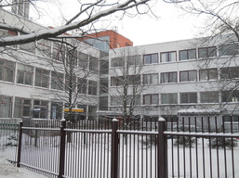
Culture and Education Studio "Talent City" started its operation on January 10, 2011. In February the website www.talantupilseta.lv was launched and on February 8 the first jewelry making class took place. In the summer of 2011 "Talent City" completed its first free-time activity project for schoolchildren during summer holidays.
The NGO training centre has a registered educational institution status, as well as the NGO has received the status of the youth organization in the register of the Ministry of Education.
Until February 2013 a variety of craft courses were held in the rented premises in Riga, 135 Dzirnavu Street, but now the scope of offered crafts courses has been narrowed, and the organization has more activities in other areas - different projects, training courses, marketing management training, study circle methodology development, off-site training for business etc.
The NGO is active in various activities and receives funding from both Latvian funds and foreign project funds. A list of implemented projects and the current list of still on-going courses can be found on the NGO’s website: www.talantupilseta.lv

On July17, 2013, the association launched the project "Democratic study circles" (Project no. 2012.EEZ/DAP/MIC/076) supported by EEA Financial Mechanism under NGO support programs sub-project scheme, to promote the study circle method in Latvia. The project is financially supported by Iceland, Liechtenstein and Norway.
Project implementation period: 01.07.2013. - 31.12.2015.

